Gibbs is another common model of reflection that is used within the health professions. Its purpose is to help you reflect on any event you have experience and it works particularly well with emotionally charged experiential events.
Gibbs is clear and precise allowing for description, analysis and evaluation of the experience helping the reflective practitioner to make sense of experiences and examine their practice.
To reflect, on its own, is not enough; you then must put into practice the learning and new understanding you have gained therefore allowing the reflective process to inform your practice. Taking action is the key and Gibbs prompts the practitioner to formulate an action plan. This enables the reflective practitioner to look at their practice and see what they would change in the future and how they would develop/improve their practice.

Gibbs (1988)
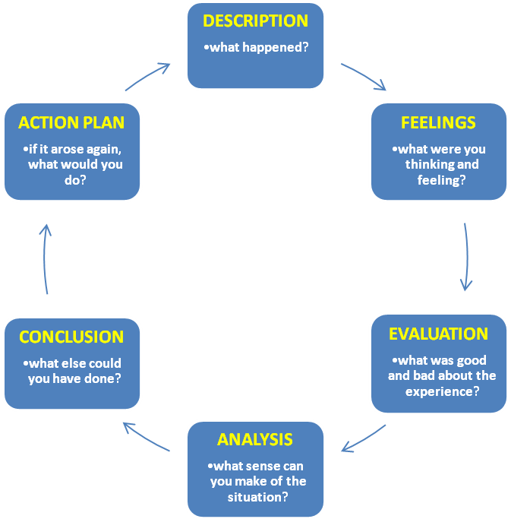

Gibbs, G. (1988). Learning by Doing: a guide to teaching and learning methods.
London: Further Education Unit,

Gibbs (1988) model of reflection
Description
This is context of the event.
In other words,
- Who was there?
- Why were you there?
- What was happening?

Feelings thoughts
This is self-awareness.
In other words,
- How did you feel?
- How did the others around you feel?
- How did you feel about the outcome of the event?

Evaluation
Consider your judgments.
In other words,
- Consider what went well, what not so well.
- What was good and not so good about your experience

Analysis
Break down the event and explore each part separately.
You may need to ask yourself more detailed questions.

Conclusion
This is the synthesis stage.
During this stage you should be exploring what you could have done differently.

Action plan
Consider what you would do differently if you encountered this situation again.
In other words,
- Would you act differently or do the same?

